Removing previous semester courses from subject course outline

Step 1: Navigate to your class page ( for eg: ENG-1-S)

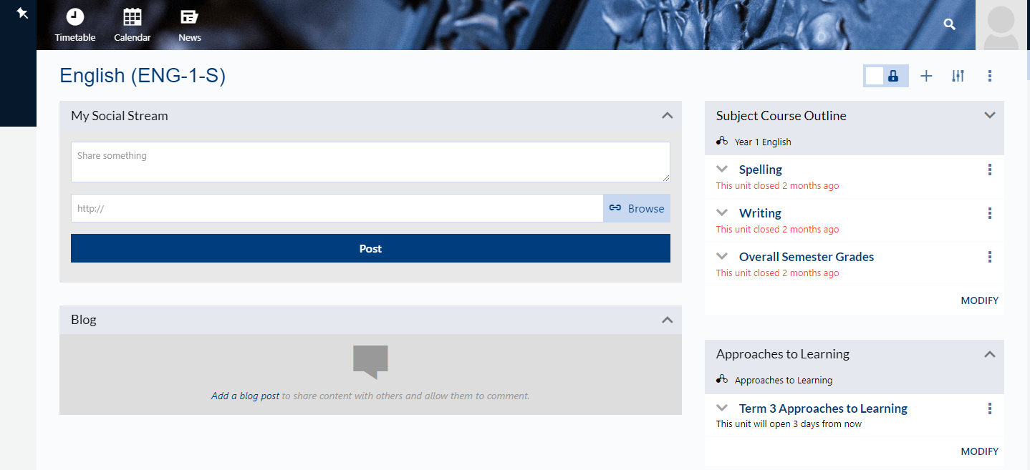

Step2: Modify an imported course on class page
Navigate to the Course Outline component on your Class Page and select ‘Modify’.

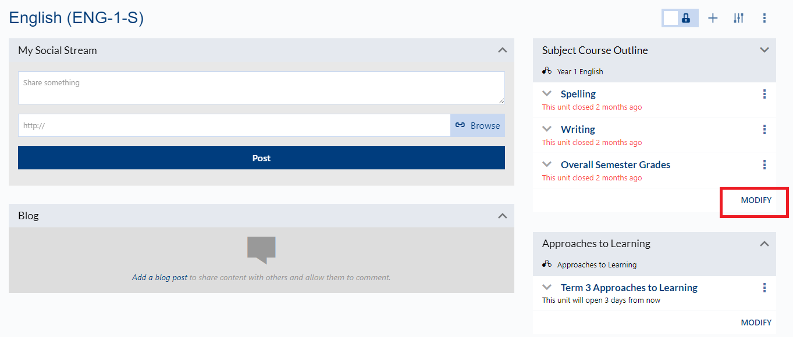

Step 3: Use the checkboxes to select the units you wish to import or unselect those you wish to delete.

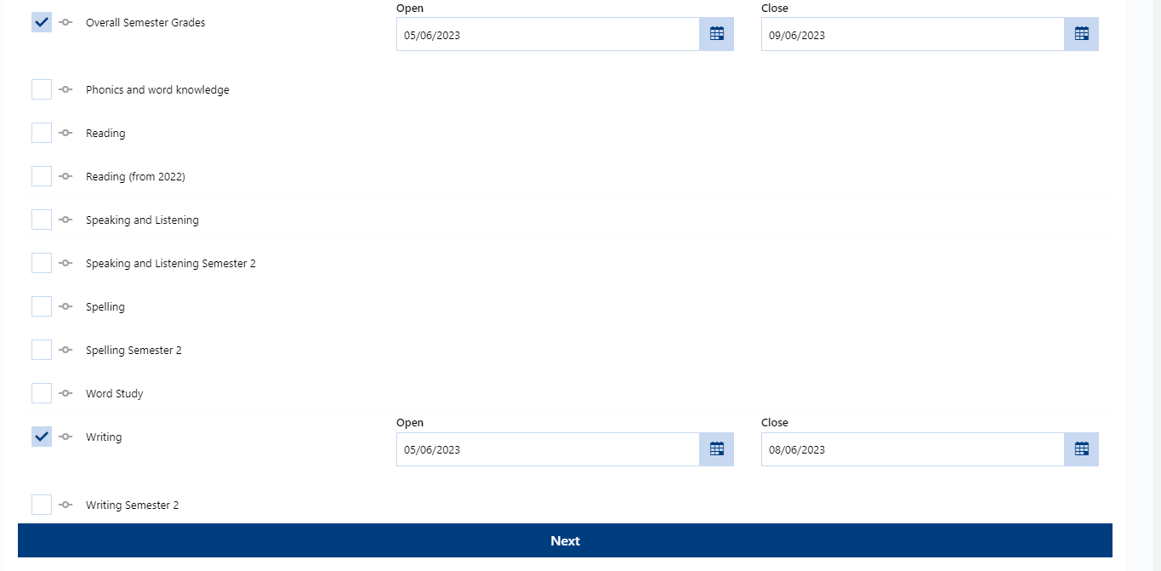
When you uncheck any box corresponding the course, a message will pop-up to get your confirmation, please proceed to ‘yes’
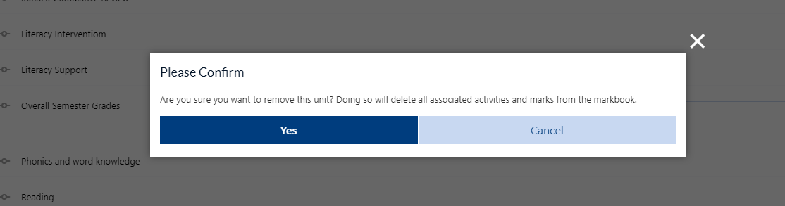

Step 4: Proceed to ‘Next’ and then ‘Modify’

